NAKLAWI: A Prototype For An Inteligent Diagnosing And Knowlede Mobile Platform For Palm Care

Zainab Al-Badi
Computer Information Systems
Imam Abdulrahman bin Faisal University
Dammam, Saudi Arabia
2220002372@iau.edu.sa

Doja Alnemer
Computer Information Systems
Imam Abdulrahman bin Faisal University
Dammam, Saudi Arabia
2220002855@iau.edu.sa

Albandary AlAmer
Computer Information Systems
Imam Abdulrahman bin Faisal University
Dammam, Saudi Arabia
amalamer@iau.edu.sa

Hebah Altheyab
Computer Information Systems
Imam Abdulrahman bin Faisal University
Dammam, Saudi Arabia
22200001030@iau.edu.sa

Donia Alfarhan
Computer Information Systems
Imam Abdulrahman bin Faisal University
Dammam, Saudi Arabia
2220004173@iau.edu.sa

May Aldossary
Computer Information Systems
Imam Abdulrahman bin Faisal University
Dammam, Saudi Arabia
mialdossary@iau.edu.sa

Zinab Alrashed
Computer Information Systems
Imam Abdulrahman bin Faisal University
Dammam, Saudi Arabia
2220003194 @iau.edu.sa

Hina Gull
Computer Information Systems
Imam Abdulrahman bin Faisal University
Dammam, Saudi Arabia
hgull@iau.edu.sa

Abstract— Date palms are playing a core role in Saudi Arabia and the Gulf region's culture and economy. However, the reduction of traditional farming expertise, raising the risk of brown spots and white scale diseases among date palms, and the lack of access to professional guidance bring the challenge of effective pest and disease management. Traditional machine learning models perform well in controlled environments, but they often fail in real-world circumstances such as complex backgrounds and variable lighting. This paper introduces Nakhlawi, a mobile-based system that deploys Convolutional Neural Networks (CNNs) and computer vision for an automated disease and pest diagnosis system. The framework allows users to upload images of the diseases for instant analysis, ensuring accurate confidence-based diagnostic reports and specialized treatment advice. Nakhlawi implements a hybrid approach by integrating digital knowledge support systems and direct consultation with agricultural experts when the system's AI confidence is low. Nakhlawi ensures early detection, minimizes financial losses, and promotes agricultural sustainability. This fills the gap between traditional practices and deep learning and guarantees the preservation of palm-growing heritage for future generations.

Keywords— Computer Vision, Deep Learning, Date Palm Diseases Diagnosis, Mobile Application.

Introduction
Achieving the Sustainable Development Goals depends heavily on the palm industry. Planning future plantings, managing orchards, and forecasting harvests all depend on accurate palm tree identification and counting [1].
Representing prosperity, heritage, and sustainability, Date palms are vital agricultural and cultural resources in Saudi Arabia. They contribute significantly to food security, the industrial sector in production, trade, and the national economy [2]. These trees need specific ingredients from their surroundings to grow and thrive. The most important thing to do in order to cultivate a healthy palm tree is to make sure it gets adequate nourishment and is safe from diseases. Nutrient deficiencies can lower dates yield and ultimately result in tree death if improperly managed. Therefore, maintaining tree health and a high yield depends on early detection and correction of these deficits.
However, numerous individuals lack the necessary skills and information for appropriate tree maintenance, pest control, and disease diagnosis, particularly small-scale palm owners like homes and community centers. It is challenging for younger generations to get trustworthy advice in areas where traditional farming knowledge, which is typically held by older farmers, is gradually declining. In addition to increased economic losses and decreased output, this circumstance puts palm cultivation-related cultural customs at risk of disappearing [3]. To address these challenges, this paper presents a framework and a mobile application prototype for palm care, diseases, and pest identification. In addition to providing seasonal fertilization and irrigation reminders and a mini-wiki for information acquisition, it uses computer vision, artificial intelligence, and other technologies to diagnose palm disease and pests. Through a consultation platform, it also links palm owners with agricultural specialists to provide safe guidance and facilitate knowledge sharing. For small-scale owners, the framework aims to enhance palm management and preserve agricultural history by offering a practical, accessible, and adaptable alternative. The paper is arranged as follows:

Literature Review
The Saudi date palm industry faces a critical generational knowledge gap, where the loss of traditional expertise has left new growers unable to effectively identify and manage leaf-based diseases. The agricultural and economic damage results from the inability to diagnose leaf-related issues. The Nekhlawi project addresses this by digitizing expert knowledge through an AI-powered platform for automated palm leaf detection. The project provides a way for leaf disease diagnosis to shift the traditional ML to operational DL to support and protect our culture. Namoun et al. (2024) [4]; Ahmed & Ahmed (2023) [5]; Qadri et al. (2024) [6] disused reliable palm leaf diagnostic tests depend on high-quality datasets as their essential foundation. Data collection uses smartphones and DSLR cameras to capture actual symptoms which result from fungal and pest-related disorders under different natural lighting conditions. Ahmed & Ahmed (2023) [5]; Qadri et al. (2024) [6] mentioned the model achieves its target accuracy because preprocessing methods use image normalization together with resizing to remove both noise and lighting interference. The research utilizes data augmentation methods to create additional information in the dataset while preventing overfitting in the model. Ahmed & Ahmed (2023) [5] mentioned these methods result in a significant improvement in performance, with accuracy levels rising to 100% after training on various augmented images. Harakannanavar et al. [7] and Hessane et al. [8] speak about how initial approaches to palm health monitoring methods were based on image processing methods (color thresholding, edge detection, and K-means clustering). Often these studies made use of texture analysis in order to recognize disease spots on the leaves. Hessane et al. [8] also went further to show that when these handcrafted features are incorporated in the classical machine learning models such as the Support Vector Machines (SVM), the various stages of infection of White Scale disease can be classified with an accuracy of 98.29. The architecture proposed by Ahmed and Ahmed [5] is called the Modified Residual Network (MResNet) and it reached 100 percent validation accuracy on augmented networks to identify the Brown Spots and White Scale problems on palm leaves. In their work, they pointed out the significance of high level of accuracy being a direct result of massive preprocessing. Moreover, Ahmed and Ahmed [5] determined that MResNet was superior to other models such as standard ResNet and Inception-Residual Network in detecting the palms infected with the two conditions with a 99.62 accuracy. Abu-Zanona et al. [9] and Mohd Sagheer et al. [10] pointed to the shift to deep convolutional models, as models such as MobileNetV2 and DenseNet, have demonstrated better performance compared with prior approaches to machine learning in classifying significant visual symptoms such as Brown Spots and White Scale. These models offer effective and scalable models that can be implemented on mobile devices to be used in real time fields by palm owners. Moreover, several studies have proposed advanced artificial intelligence models for detecting and classifying date palm diseases—for example, Mostafa Ahmed and Ali Ahmed developed a deep learning model based on Inception-ResNet for palm disease detection [5], and Hassan and others developed a machine learning framework for the stage-wise classification of date palm white scale disease —the proposed solutions were primarily based on a technical framework of algorithms lacking an integrated system and direct user interfaces [8].Mohammed Karar and others also presented Internet of Things (IoT)-based solutions, as did Yaseen Al-Mulla and Amna Al-Ruehelli, which utilize drones for detecting date palm diseases and monitoring their health [18-19]. However, these solutions require specialized equipment and advanced technical expertise, making them less accessible to non-technical users. Consequently, these existing solutions often remain overlooked or limited to large farms due to their reliance on on-site experts and expensive, specialized equipment, thus restricting their adoption as a sustainable solution.

Problem statement
Date palm is among the most significant crops in Saudi Arabia and the Gulf region not only as a food and source of income but also as a symbol of culture and heritage. In a value chain study conducted on date palm in the Arab region FAO and AOAD found evidence that date palms have been present in the region since around 4000 BC [11]. Today, palm trees now are considered a key component of a national and regional economy through local consumption, exports, and tourism events such as date festivals. According to the National Center for Palms and Dates, Kingdom's date exports in 2024 amounted to more than 1.695 billion Saudi riyals [12].
Despite this importance, through the literature we have analyzed that date palm owners, especially small farmers and home growers, face ongoing challenges in managing their trees effectively. Date palm cultivation is surrounded by a wide range of threats. Palm trees face major challenges, the most important of which are pests and diseases that significantly impact palm production in the region, which, if left untreated, lead to reduced production, tree death, and economic losses equivalent to 28% of total production. These threats include insect pests, fungal infections, and nutrient deficiencies [11]. Day by day these problems are exacerbated by the younger generation's uninterest in palm cultivation. In Al-Ahsa Oasis a study revealed that most farmers were over 40 years old, and their knowledge risks being lost in the absence of proper documentation or accessible sharing methods (see Figure 1) [13].

Figure 1: Age of palm farmers in Al-Ahsa Oasis

The current digital solutions used in the Gulf region remain limited and fragmented, primarily designed for large farms or government initiatives. Studies show that Arab agricultural applications are relatively few compared to their global counterparts, and that older or less educated farmers often struggle to adopt mobile technologies, facing barriers in language, ease of use, and digital literacy [14]. As a result, smallholders and inexperienced palm owners remain underserved and lack easy-to-use and accessible tools that meet their daily needs.
This gap is further increased by the lack of digital platforms solution tailored toward gulf countries. Without interventions that combine modern diagnostic tools, practical guidance, and mechanisms for preserving specialized knowledge, the region risks losing agricultural competencies over time. This unresolved problem highlights the urgent need for solutions that link technological accessibility with agricultural sustainability.

METHODOLOGY
This paper proposes a framework named Nekhlawi, and its details are as follows:

Nekhlawi high-level architecture
The high-level framework of Nekhlawi system follows a layered structure consisting of user interface and expert interaction, artificial intelligence, and Palm Care Hub to facilitate disease diagnosis and professional consultation (see Figure 2).
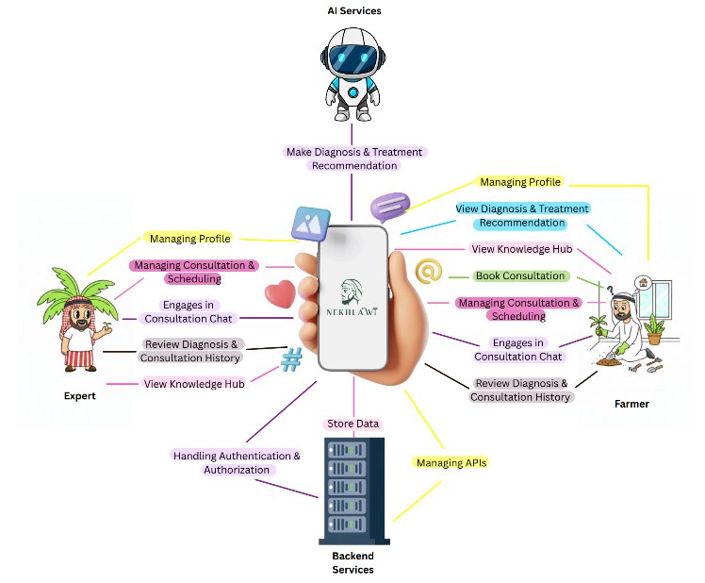
Figure 2: Overview Diagram

Nekhlawi operational layer
- User Interface Layer: this layer consists of two classes of users: Palm Owners use the application to upload images within AI diagnosis and treatment tool, book consultation sessions, view past AI diagnosis and treatment, and previous consultations. Agricultural Experts interact with interfaces to manage their consultation schedules, review their client requests, and provide real time guidance.
- Intelligence Layer: this layer is the “heart” of Nekhlawi application, it will apply deep learning models and image processing to analyze uploaded images of palm leaves or trunks to detect pets (Brown spots, White spots, Fusarium Wilt) and diseases. If the AI model detects the issue with high confidence (typically >= 60%), it will generate a diagnosis and treatment recommendations.
- Knowledge Layer: this will provide a digital bridge between traditional farming and modern technology.
- Expert Interaction Layer: this layer will facilitate the connection between users and experts: Real time communication: supporting chat, video calls, voice notes. Scheduling and billing: Handling the appointments, verifying expert availability.

Mobile Application Architecture
The architecture of the Nekhlawi mobile application is based on a client–server architecture, where the mobile client handles tasks such as user interactions and image capturing, representing the front-end of the app, while the backend server handles image processing, authentication, and other tasks. However, to achieve scalability and security, this structure was also combined with a layered structure as follows.

Mobile Application Components:

Client Mobile
The client's mobile acts as the front-end component of the application. It is implemented using the three layers listed below:
- Presentation layer: it is the interface that appears to the user to manage the interaction between them and the application
- Business Logic layer: in addition to enforcing the business rules, it also manages the data flow as it links between the data and presentation layers
- Data layer: manages data and manages interaction with external components
The responsibilities of this layer include the following tasks:
- Providing a user interface
- Collects images and captures pictures from the device's gallery or camera
- Sending images to the backend
- Displays the confidence level and the disease detection results,
- show treatments recommendations
- Connecting users with experts for consultations

Backend Server
The backend server communicates with AI services, controls data flow with API usage and handles the authentication and authorization services. Its role is to be the central processing component and coordinate other layers.

AI Services
The main role of AI is to extract features from collected images to classify diseases and detect them to provide treatments recomindations through out machine learning and give the results back to the end servers. This component will host the model as a cloud-based service.

Database
The in this layer Supabase designed to stores the following data:
- User information
- Historical consultation records
- Mini-wiki articles
- AI service results
The clear separation of each layer eases the maintenance of the application and provides secure communication and controlled access. Cloud-based services allow the application to perform faster and reduce the load on mobile devices; moreover, they allow the application to be scalable. Lastly, having a simple user interface boosts usability.

Nekhlawi Dataset
gg

Models Used

Integration of AI, ML, image processing, and backend services
The application aims to achieve an efficient and accurate disease detection and diagnosis; thus, it integrates several technologies. After using image processing techniques to resize the image and enhance its overall quality, the machine learning model is designed to detect diseases using a CNN-based classifier. AI services will recommend treatment based on the machine learning model results, while backend services and databases store the results, other related data, and user information to provide authorization and authentication services.

Data flow between components
- Input: The process of diagnosis begins with the user either uploading an image of the palm from their phone gallery or by capturing a live image of the palm through the app’s interface.
- Processing: After acquiring the image from the user, the cloud-based model will process it by applying preprocessing techniques and then applying the analysis.
- Output: after processing and according to accuracy and confidence level threshold, the output will be displayed as interpretation or diagnosis in the app to the user.
- Storage and retrieval: each diagnosis made, along with user profiles and consultation logs will be automatically saved in the backend storage system and ready to be retrieved from the user.
- Expert feedback: if the processing didn’t meet the threshold of confidence level, the user will be transitioned to seek professional help from an expert which can share images with to get human validation.

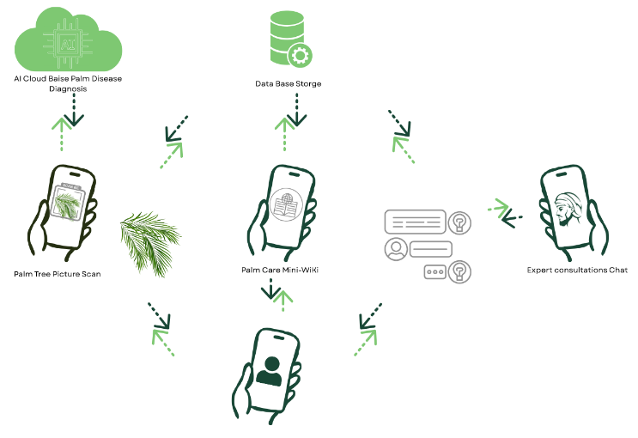

Figure 3: Overview of data flow between components

Image Scanning and Diagnosis Module
The system will acquire images easily from the user either by uploading it from their mobile device or capturing a real time image by the device’s camera. After acquiring the image, the model will subject it to image preprocessing techniques like Morphological Analysis for noise reduction and structural refinement and then start to perform image processing. The model is trained with a labeled data set that was subject to preprocessing techniques like normalization, resizing and enhancement. What is considered as an intelligence layer will utilize supervised machine learning and computer vision trained on infected and healthy date palm tree leaves, the model is designed to diagnose diseases like and target to reach an output with an accuracy of at least 90%, the output should reach a confidence level of (>=60%) as a threshold to start the interpretation process and display it to the user as a diagnosis, however if the output has a level of confidence of (<60%) the user will be informed of that and will be suggested to seek professional help by a real expert.

Evaluation Method

Results

Model Performance

Performance Comparison

Discussion
As the Nekhlawi framework focuses on addressing the most important issues of date palm farming in Saudi Arabia and the Gulf region, the traditional farming methods are combined with the modern methods of deep learning and computer vision, which will provide a complete solution to the problem. The framework solves the problems of economic losses and slow extinction of agricultural expertise by computerizing the expertise of experts using AI-based technology. Nekhlawi combines CNN-based diagnostic models that have the ability to recognize palm diseases and pests with high accuracy and also uses a confidence threshold (≥60) to make sure that only sound treatment recommendations are provided to the users. In case of a lack of confidence levels, the system will refer customers to human agricultural experts and maintain trust and retain expert judgment in the decision-making process.
Besides automated diagnosis, the framework also assists in knowledge retention and transfer by means of an online mini-wiki and organized treatment instructions, which may aid in preserving farming experience when the knowledge of seasoned growers is lost with their retirement. The client-server architecture and the mobile-first design increase the level of security, scalability, and convenience, allowing the platform to be accessible to small-scale farmers and home growers with different degrees of digital literacy. The Nekhlawi framework helps to maintain the cultural importance of the crops, decrease the economic losses, and encourage the use of sustainable agricultural practices in the region by providing the opportunity to monitor the palm health, detect the diseases early, and offer the advisor-supported recommendations.

CONCLUSION
The Nekhlawi project offers complete solutions which solve all important problems that Saudi Arabia and Gulf countries face in their date palm farming operations by combining traditional farming methods with contemporary deep learning methods. The framework prevents economic downturns and cultural heritage loss which results from expert knowledge erosion by creating digital expert knowledge through an AI-powered platform. The proposed system successfully integrates advanced AI diagnostics, utilizing CNN-based models to offer high-accuracy disease and pest detection, which requires at least 60% confidence level to provide dependable treatment recommendations. The platform supports knowledge retention through its digital mini-wiki system while establishing trustworthiness through its system which connects users to human agricultural experts when AI confidence levels drop. The mobile-first client-server architecture which uses a layered design enables the platform to achieve three objectives which include secure operation and accessibility for small-scale farmers who have different levels of digital skills. The Nekhlawi framework implementation will lead to better palm health management practices which protect crops that hold cultural significance for the region while preventing economic losses. The project should develop its intelligence system to detect a larger range of palm trunk diseases and nutrient deficiencies, while the project team should continue to gather various datasets which will strengthen the model performance. The platform will provide automatic seasonal reminders, which will support users in Arab countries, while its expansions will enable the system to handle increased demands from new users who join the platform.

acknowledgments

References

[1] Y. Hajjaji, W. Boulila, I. R. Farah, and A. Koubaa, “Enhancing palm precision agriculture: An approach based on deep learning and UAVs for efficient palm tree detection,” Ecological Informatics, vol. 85, p. 102952, 2025, doi: 10.1016/j.ecoinf.2024.102952.
[2] KSA’s World Heritage List - date palm, knowledge, skills, traditions and practices,” KSA for UNESCO, https://ksaforunesco.org/heritages/date-palm-knowledge-skills-traditions-and-practices/ (accessed Sep. 29, 2025).
[3] A. I. Aldakhil et al., “Evaluating the economic impact of Integrated Pest Management (IPM) on Smallholder Date Palms Farmers - Journal of the Saudi Society of Agricultural Sciences,” SpringerLink, https://link.springer.com/article/10.1007/s44447-025-00035-6 (accessed Sep. 29, 2025).
[4] A. Namoun, A. B. Alkhodre, A. A. Abi Sen, Y. Alsaawy, and H. Almoamari, “Dataset of Infected Date Palm Leaves for Palm Tree Disease Detection and Classification,” Data in Brief, vol. 57, no. (2024), Art. no. 110933, Sep. 2024, doi:10.1016/j.dib.2024.110933.
[5] M. Ahmed and A. Ahmed, “Palm tree disease detection and classification using residual network and transfer learning of inception ResNet,” PLoS ONE, vol. 18, no. 3, p. e0282250, Mar. 2023, doi: 10.1371/journal.pone.0282250.
[6] S. A. A. Qadri, N.-F. Huang, T. M. Wani, and S. A. Bhat, “Advances and Challenges in Computer Vision for Image-Based Plant Disease Detection: A Comprehensive survey of machine and deep learning approaches,” IEEE Transactions on Automation Science and Engineering, vol. 22, pp. 2639–2670, Apr. 2024, doi: 10.1109/tase.2024.3382731.
[7] S. S. Harakannanavar et al., “Plant leaf disease detection using computer vision and machine learning algorithms,” Global Transitions Proceedings, vol. 3, no. 1, 2022.
[8] A. Hessane, A. E. Youssefi, Y. Farhaoui, B. Aghoutane, and F. Amounas, “A machine learning based framework for a Stage-Wise classification of date Palm White Scale disease,” Big Data Mining and Analytics, vol. 6, no. 3, pp. 263–272, Apr. 2023, doi: 10.26599/bdma.2022.9020022.
[9] M. Abu-Zanona, S. Elaiwat, S. Younis, N. Innab, and M. M. Kamruzzaman, “Classification of Palm Trees Diseases using Convolution Neural Network,” International Journal of Advanced Computer Science and Applications, vol. 13, no. 6, 2022.
[10] Sagheer, S. V. M., Orwel, P. V., Ameer, P. M., BaQais, A., & Kalathil, S. (2025). A Deep Learning Approach to Classification of Diseases in Date Palm Leaves. Computers, Materials & Continua.
[11] FAO and AOAD, Value chain study – Date palm in the Arab region, Cairo: FAO, 2023. [Online]. Available: https://openknowledge.fao.org/server/api/core/bitstreams/ec3c70f9-b773-44de-9fc3- a5ae6a922cb8/content.
[12] “والتمور للنخيل الوطني المركز“, Available: https://ncpd.gov.sa/en/news/32.
[13] “FAO Knowledge Repository”, Available: https://openknowledge.fao.org/items/056f87cf-29f6-4493-aa48-0312dbcbb127?.
[14] M. Alshehri and O. Alharbi, “Understanding the Landscape of Leveraging IoT for Sustainable Growth in Saudi Arabia,” Jul. 2024, doi: 10.48550/arxiv.2407.04273. Available: https://arxiv.org/pdf/2407.04273.
[15] M. Safran, W. Alrajhi, and S. Alfarhood, “DPXception: A lightweight CNN for image-based date palm species classification,” IEEE Access, vol. 11, pp. 112345–112356, 2023.
[16] K. A. Y. Galala, “Web-based expert system for diagnosis of date palm diseases,” International Journal of Computer Applications, vol. 183, no. 25, pp. 1–7, 2021.
[17] M. Karar, S. Al-Mousa, A. A. El-Sayed, and A. Darwish, “Smart IoT-based system for detecting RPW larvae in date palms using mixed depthwise convolutional networks,” Alexandria Engineering Journal, vol. 61, no. 12, pp. 10237–10249, 2022.
[18] M. E. Karar, A.-H. Abdel-Aty, F. Algarni, M. F. Hassan, M. A. Abdou, and O. Reyad, “Smart IoT-based system for detecting RPW larvae in date palms using mixed depthwise convolutional networks,” Alexandria Engineering Journal, vol. 61, no. 12, pp. 10237–10249, 2022, doi: 10.1016/j.aej.2021.12.037.
[19] Y. Al-Mulla and A. Al-Ruehelli, "Use of Drones and Satellite Images to Assess the Health of Date Palm Trees," IGARSS 2020 - 2020 IEEE International Geoscience and Remote Sensing Symposium, Waikoloa, HI, USA, 2020, pp. 6297-6300, doi: 10.1109/IGARSS39084.2020.9324065.

